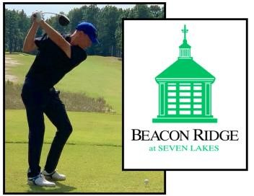**Learn Golf 2025**

**Bill Baker Teaching Professional**

**910-783-6486**

**bill@beaconridgecc.com**

Helping all skill levels enjoy the game, Bill’s individualized lessons include slow motion video analysis, launch monitor interpretation, easy to adopt practice drills, and helpful tips to take to the course. You will get to work on your game at the range, practice greens and on the golf course. 25th year teaching and coaching golfers of all ages in the Sandhills. **Schedule an hour for $75 to find out what a good swing feels like! Series of 5 lessons 45 minutes each for $300)**

* Youth and adult group clinics run March-May,
* Summer Camps for 7–12-year-olds June-July
* Buy new or used US Kids Golf clubs and training aids from Bill



**2025 Golf & Games**

**Summer Camps**

**June – July TBA**

Reserve a spot in our fun-filled golf & games half-day summer camp.

Mornings from 8am to 11:30am.

For all skill levels ages 7-12. $175 each. Snack included.

This is outdoor, active and social! Please wear sneakers that can get dirty.